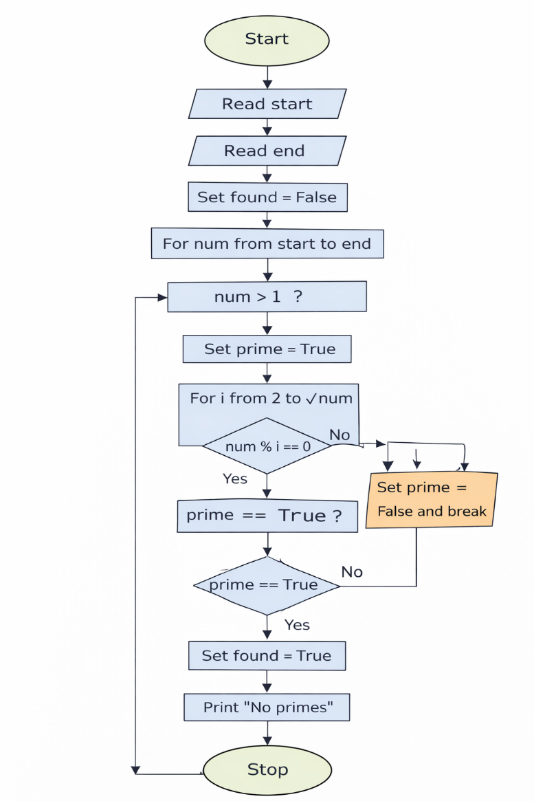
ALGORITHM
- Start
- Read start
- Read end
- Set found = False
- For num from start to end
- If num > 1
- Set prime = True
- For i from 2 to √num
- If num % i == 0
- Set prime = False and break
- If prime == True
- Print num
- Set found = True
- If found == False
- Print "No primes"
- Stop

8.1.2 PRIME NO IN A GIVEN RANGE

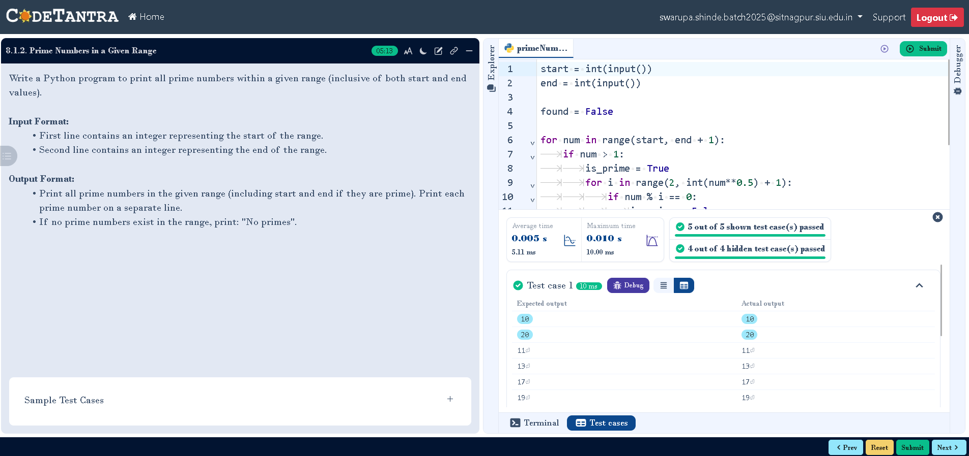
Code:

